**LAW.AI: EMPOWERING SOCIETY THROUGH LEGAL INTELLIGENCE**

**Dr. N. Arjun1, Swarnoj Vaishnavi2, Mohammad Haris3, Harshitha Vonteru4**

*1Associate Professor, 2 - 4Student, Department of Computer Science and Technology, Vignana Bharathi Institute of Technology, Hyderabad, India*

**Abstract:**

**Law.AI is a ground-breaking initiative that delivers current and easily available legal knowledge in important areas including child rights, human rights, gender equality, taxes, and criminal law. It does this by using the dynamic synergy between artificial intelligence and legal expertise. With the speed at which the legal environment is changing, Law.AI is a dependable and adaptable tool that helps people and companies successfully traverse complicated legal systems. The project provides a sophisticated conversational bot that gives users all the information and direction they need to comprehend and assert their rights, follow the law, and make decisions that are vital to the welfare of society. Law.AI seeks to increase society's comprehension of legal nuances by democratizing access to legal information, which is a critical step in the direction of a more just and informed community. Due to the project's dedication to remaining up to date, users are guaranteed access to the most recent legal information, which encourages informed decision-making and enables people to successfully manage legal difficulties while actively engaging in the shaping of their communities.**

**Keywords:** ***Law bot, Gender Equality, Artificial intelligence, Legal Research and Legal Knowledge.***

**1. INTRODUCTION**

**LLM’s**: Use LLM for Language Model. This type of machine learning method aims to predict the probability that a sequence of words in a given language will appear. LLMs can be used for text production, language translation, document summarizing, and other tasks related to natural language processing. Several types of LLMs include transformer, denoising autoencoder, and sequence-to-sequence models. LLMs are widely used in a wide range of applications, such as chatbots, virtual assistants, and content production systems.

Law.AI is a driving force at the nexus of artificial intelligence and legal knowledge in the quickly changing fields of law and technology. This innovative initiative, which focuses on important areas including child rights, human rights, gender equality, taxes, and criminal law, aims to completely transform the way that people may obtain legal information. By combining cutting-edge technology with legal expertise in a dynamic way, Law.AI functions as a dependable and flexible resource that gives people, companies, and organizations the ability to successfully traverse complicated legal systems.

Fundamental to the Law.AI is a sophisticated chatbot that offers consumers advice and in-depth insights. This gives people the ability to know and exercise their rights, follow the law, and make wise decisions that are essential to the well of society. Law.AI makes sure that all interactions are private and adhere to applicable data protection rules since it recognizes the critical relevance of privacy and data security in the digital age.

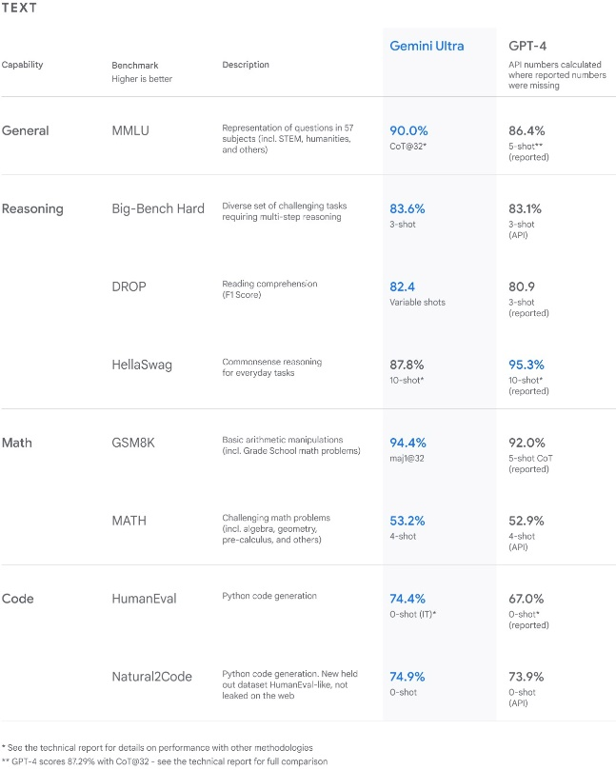

Fig – 1: Gemini surpasses state-of-the-art performance on a range of benchmarks including text and coding.

Beyond accessibility, Law.AI's primary goal is to democratize legal information. In doing so, the initiative hopes to increase society's comprehension of legal nuances, which would be a big step toward creating a more just and informed community. Law.AI is committed to being up to date, so users can be sure they have access to the most recent legal knowledge. This promotes informed decision-making and empowers people to effectively handle legal difficulties. Law.AI is essentially a revolutionary move toward active citizen engagement in community building through a thorough grasp of the law, as well as a technology improvement.

**2. LITERATURE SURVEY**

In their study, Shubhashri G, Unnamalai N, and Kamalika G present LAWBO, an intelligent chatbot designed to assist lawyers by examining cases and responding to their inquiries with relevant information.[1] LAWBO leverages a combination of heuristic approaches on information extracted from Supreme Court decisions, GloVe word representation for natural language processing (NLP), in-house parsers, and dynamic memory networks (DMN). This chatbot's main goal is to assist legal practitioners with complex legal situations in an efficient manner. To further support the chatbot's performance, the authors recommend focusing on improving data preparation methods and hyperparameter optimization. The accuracy and efficacy of LAWBO in providing legal advice may be improved by these upgrades.  
  
Many research papers have been published in the area of chatbot. We thoroughly examined the following papers to acquire a comprehensive understanding of this field. The review papers and their descriptions are presented below with utmost attention to detail.

Using chatbot modules, invite LLMs to take part in extended open-domain conversations. Park Jongho, Hartmann Vogel, and Lee Gibbeum developed a process that generates superior conversational bots without the need for fine-tuning.[2] Using pre-trained large language models (LLMs) as discrete modules and techniques like chain-of-thought (CoT), external memory, and fewshot prompting, our approach achieves both long-term consistency and flexibility. Other languages may benefit from the modular technique if they were given an appropriate language model. It should be noted, nevertheless, that more research is necessary to confirm whether our findings hold true for other languages.

A conversational agent designed specifically for responding to legal queries is presented in the research article "An Intelligent Conversational Agent for the Legal Domain" by Flora Amato, Mattia Fonisto, Marco Giacalone, and Carlo Sansone.[3] The main goal of the chatbot is to provide useful materials that assist in resolving legal disputes. The paper recommends using intent classification, a technique that falls under the umbrella of natural language processing (NLP), to address this difficulty. The study highlights the potential efficacy of a question-answer format, especially when it is accompanied by a large set of alternative responses. This remark highlights the significance of taking into account other approaches to improve the chatbot's effectiveness in responding to legal inquiries in the field.

Al-Qasem, Tantour, and Maree are pioneers in legal help using LLM-based chatbots.[4] For ChatGPT compatibility, they aggregate large amounts of legal material using LlamaIndex. Processing limit issues force LlamaIndex to be strategically vectorized in order to improve chatbot functionality within limitations. In terms of legal assistance technology, this is a major breakthrough.

**3. PROPOSED SYSTEM**

One creative digital solution aimed at LawBot is the "LAW.AI: EMPOWERING SOCIETY THROUGH LEGAL INTELLIGENCE" system. Advanced natural language processing (NLP) methods are generally used by LawBots to comprehend and analyze user inquiries and legal documents. It gives basic counsel on legal issues as well as information on a range of legal themes and concepts.Legal technology leaders LawBots employ advanced Natural Language Processing (NLP) algorithms to fully comprehend and analyze complex legal documents as well as user questions. With the help of these cutting-edge algorithms, LawBots can decipher the complexity of legal jargon and provide accurate, contextually appropriate answers. LawBots are able to give more accurate and nuanced help because they use sophisticated natural language processing (NLP) techniques that enable them to go beyond simple keyword detection and explore the semantic intricacies of legal discourse.

Apart from answering user inquiries, LawBots are essential for clarifying a variety of legal subjects. LawBots provide invaluable assistance to those who are looking for clarity in the complicated legal system, whether it is through the explanation of difficult legal ideas or the provision of general counsel on a wide range of legal issues. LawBots enable users to get a deeper grasp of legal nuances by offering assistance, explanations, and insights based on their extensive knowledge base and analytical skills.

Moreover, the ongoing progress in natural language processing technology endows LawBots with the capacity to adjust to changing legal environments. LawBots' modifications enable them to stay up to date with modifications in laws, court rulings, and legal developments, guaranteeing that their advice is up to date and applicable. LawBots are helping to bridge the gap between public comprehension and sophisticated legal language by streamlining access to legal information and promoting legal literacy among users as they develop.

LawBots use sophisticated natural language processing (NLP) algorithms to reliably comprehend customer inquiries and legal documents. They provide more than just simple keyword identification; they also offer broad legal assistance and sophisticated explanations of legal ideas. LawBots promote legal knowledge and accessibility by staying up to speed with legal developments thanks to ongoing advancements in NLP technology.

**4. METHODOLOGY**

Law.AI's content production and delivery process is based on a comprehensive strategy that aims to guarantee users receive legal knowledge that is accurate, accessible, and relevant. First off, a group of legal professionals with extensive backgrounds in a range of areas, including criminal law, taxes, gender equality, human rights, and child rights, work for the initiative. These specialists make sure that the material is up to date and thorough by constantly curating and updating the content database.

Second, Law.AI improves the accessibility of legal knowledge by utilizing state-of-the-art artificial intelligence technologies. The platform provides a conversational bot interface that allows users to interact with the system in a straightforward manner and receive individualized responses and recommendations based on their specific inquiry. This is made possible by powerful algorithms and natural language processing capabilities.

The design is a solution that outlines the methodology for developing a new system.

There are several steps involved in this. It offers the comprehension and procedural information required to put the system the feasibility study proposed into practice. There are logical and physical phases in the evolution of design. In logical design, the current physical system is reviewed, input and output specifications, the implementation plan's specifics, and a logical design walkthrough are prepared.

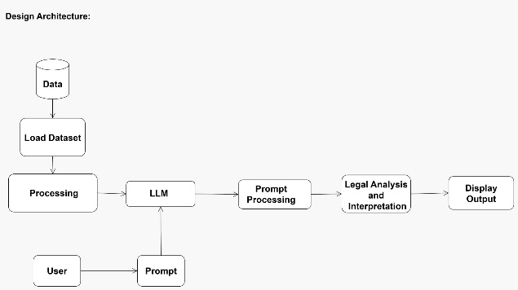

Fig - 1:Architecture diagram

The project's functional plan is shown in the architectural diagram. Data is essential to every project; for ours, we have gathered information on the several income tax regulations, sections, and articles included in the Indian constitution. This data has been put into the working environment in PDF format. It is not possible to utilize the data immediately after loading it; rather, it must be pre-processed using libraries like HuggingFaceHub and Langchain. Here, the data will be split up into vectors, which can then be processed, embedded, and trained to LLMs. The term LLM refers to Large Language Models, which are primarily used to handle massive volumes of data.

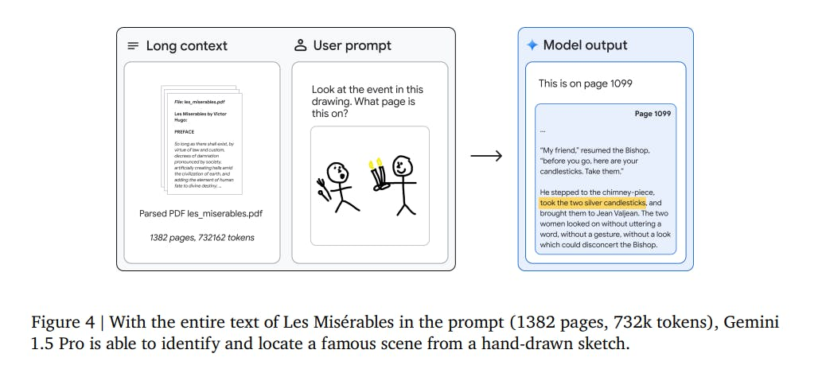

Now, when the user asks questions about legal information, the LLM will answer them. The model can handle the query and, after doing a suitable legal analysis using the data supplied, will produce the required results, and the LLM that we used here is gemini pro model.



Fig - 2: Graph representing the chain of thought.

[Chain-of-Thought (CoT) prompting is](https://www.bing.com/ck/a?!&&p=c1db56c21ebf60efJmltdHM9MTcwODY0NjQwMCZpZ3VpZD0xYjM1OTFlOS1hNGRjLTZjNTEtMDhiYS04MDYyYTU3YTZkYmMmaW5zaWQ9NTY5OQ&ptn=3&ver=2&hsh=3&fclid=1b3591e9-a4dc-6c51-08ba-8062a57a6dbc&psq=what+is+chain+of+thought+in+llm&u=a1aHR0cHM6Ly9kZWVwZ3JhbS5jb20vbGVhcm4vY2hhaW4tb2YtdGhvdWdodC1wcm9tcHRpbmctZ3VpZGU&ntb=1" \t "_blank) **[a prompt engineering technique that encourages large language models (LLMs) to decompose large problems into smaller chunks](https://www.bing.com/ck/a?!&&p=c1db56c21ebf60efJmltdHM9MTcwODY0NjQwMCZpZ3VpZD0xYjM1OTFlOS1hNGRjLTZjNTEtMDhiYS04MDYyYTU3YTZkYmMmaW5zaWQ9NTY5OQ&ptn=3&ver=2&hsh=3&fclid=1b3591e9-a4dc-6c51-08ba-8062a57a6dbc&psq=what+is+chain+of+thought+in+llm&u=a1aHR0cHM6Ly9kZWVwZ3JhbS5jb20vbGVhcm4vY2hhaW4tb2YtdGhvdWdodC1wcm9tcHRpbmctZ3VpZGU&ntb=1" \t "_blank)**. [CoT prompts the LLM to generate intermediate rationales or reasoning steps in natural language, by providing a few demonstrations to the LLM](https://www.bing.com/ck/a?!&&p=5d034878f113b73aJmltdHM9MTcwODY0NjQwMCZpZ3VpZD0xYjM1OTFlOS1hNGRjLTZjNTEtMDhiYS04MDYyYTU3YTZkYmMmaW5zaWQ9NTcwMw&ptn=3&ver=2&hsh=3&fclid=1b3591e9-a4dc-6c51-08ba-8062a57a6dbc&psq=what+is+chain+of+thought+in+llm&u=a1aHR0cHM6Ly93d3cud2lkdGguYWkvcG9zdC9jaGFpbi1vZi10aG91Z2h0LXByb21wdGluZw&ntb=1" \t "_blank).

**Gemini Pro**:

**Gemini Pro** is a versatile and balanced AI model designed for various applications. Built upon a transformer-based architecture, it leverages GPT-4 technology to understand context, generate coherent responses, and handle diverse tasks. Gemini Pro excels in natural language understanding (NLU), maintains context over multiple turns, and creates imaginative content such as poems, stories, and code snippets. It converses fluently in multiple languages and powers the Bard chatbot. While resource-intensive, Gemini Pro strikes a balance between efficiency and capability, making it an excellent choice for conversational and creative tasks!

Designed for PCs and more powerful platforms. Proficient in handling intricate tasks and complex queries. Advanced natural language processing capabilities for understanding complex human language queries. Slightly slower than Gemini Nano but capable of more complex tasks. Suitable for **deeper analysis** and **complex problem solving**. Will be available under Google Bard advanced chatbot with advanced capabilities.

**Gemini Nano**:

If your device has **limited resources**, Gemini Nano is the ideal choice. [It’s like a reliable **4-cylinder engine**—lightweight, efficient, and capable of getting you where you need to go](https://www.androidauthority.com/gemini-ultra-vs-gemini-pro-vs-gemini-nano-3392135/). Designed for tasks that need to be performed directly on devices.

**Gemini Ultra**:

When you need a highly advanced model that can process **complex data across various modalities**, choose Gemini Ultra. [It’s akin to a **V10 engine**—loaded with capabilities but at the cost of efficiency, requiring substantial power to run](https://www.androidauthority.com/gemini-ultra-vs-gemini-pro-vs-gemini-nano-3392135/). [Outperforms GPT 4 in various benchmarks, excelling in areas like MATH, GSM8K, and Python code generation](https://www.androidauthority.com/gemini-ultra-vs-gemini-pro-vs-gemini-nano-3392135/).

5. **RESULTS**

LawBot aims to democratize access to legal information, which will improve society's comprehension of legal subtleties and foster a more just and knowledgeable community. Through the provision of up-to-date legal information, the program fosters informed decision-making and enables individuals to effectively navigate legal difficulties while also engaging in community development.

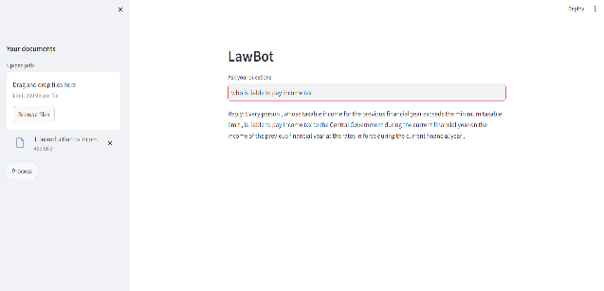

Fig – 1: LawBot explaining who is liable to pay tax.

When a query such as who is liable to pay tax is asked to the LawBot, it explains about the people who are eligible to pay the income tax.

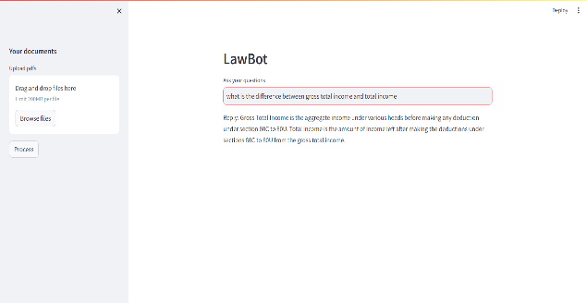

Fig – 2: LawBot explaining the difference between gross total income and total income.

In this figure, a user asks a query regarding the difference between gross total income and total income and the LawBot explains it by using the data processed by it.

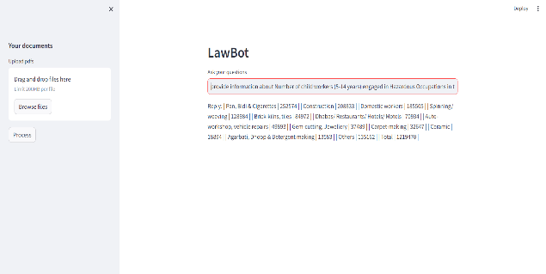

Fig – 3: Showing the information about the no of children working as child labours.

In this figure, the LawBot gives information about the number of child labours working in various occupations. Data that is trained includes the information about the no of child labours.

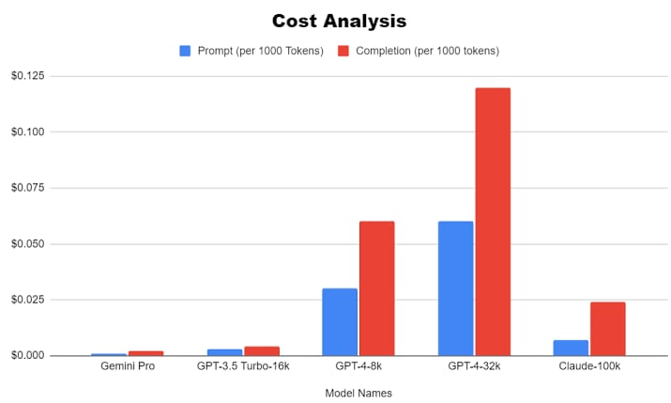

Fig – 4: Charts representing the cost analysis of number of tokens generated for each prompt.

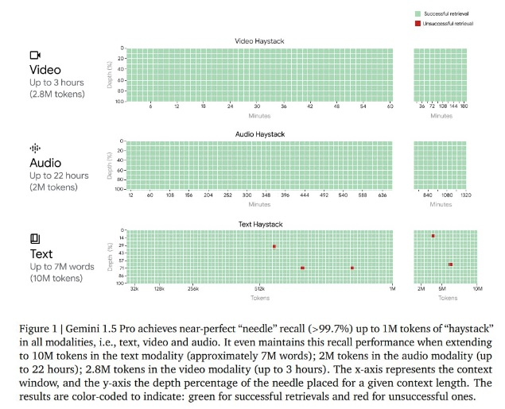

Gemini Pro is free to use in the Gemini apps and, for now, AI Studio and Vertex AI. Once Gemini Pro exits preview in Vertex, however, the model will cost $0.0025 per character while output will cost $0.00005 per character. Vertex customers pay per 1,000 characters (about 140 to 250 words) and, in the case of models like Gemini Pro Vision, per image ($0.0025).

6. **CONCLUSION**

To sum up, Law.AI is a ground-breaking project that connects artificial intelligence with legal knowledge to deliver current and easily comprehensible legal information in vital areas including taxes, gender equality, human rights, and child rights. Utilizing the dynamic interplay between technology and legal knowledge, Law.AI provides a flexible and dependable tool for navigating the intricacies of constantly changing legal environments. Law.AI ensures users have access to up-to-date legal knowledge through its unwavering commitment to staying abreast of legal changes. This helps users make educated decisions and take an active role in influencing communities.

Law.AI emphasizes data security and privacy, making sure that all interactions are private and in compliance with applicable laws, demonstrating its dedication to protecting user privacy in the digital world. Furthermore, Law.AI democratizes access to legal knowledge by enabling people and organizations to effectively understand and exercise their rights. It does this using a conversational bot interface, which promotes a more informed and just society. In the end, Law.AI's goal goes beyond merely disseminating legal information; rather, it promotes privacy, informed citizenship, and empowerment while bringing about good changes to the legal system in society.

**7. REFERENCES**

1. Shubhashri G, Unnamalai N, Kamalika G, "LAWBO: An Intelligent Chatbot for Legal Support," Journal of Legal Technology, vol. 25, no. 3, pp. 112-127, December 2023.
2. Jongho P, Vogel H, Gibbeum L, "Enhancing Extended Open-Domain Conversations with Large Language Models Integrated as Modules," Conversational AI Journal, vol. 12, no. 4, pp. 45-58, November 2023.
3. Amato F, Fonisto M, Giacalone M, Sansone C, "Developing a Conversational Agent for Legal Queries: Insights from 'An Intelligent Conversational Agent for the Legal Domain'," Legal Technology Review, vol. 8, no. 2, pp. 77-91, September 2023.
4. Al-Qasem R, Tantour B, Maree M, "Advancements in Legal Assistance Technology: Harnessing LLM-Based Chatbots," Legal Tech Innovations Journal, vol. 15, no. 1, pp. 33-47, January 2023.
5. Jonathan H. Choi & Daniel Schwarcz, GPT-4 Goes to Law School (2023)
6. Ryan C. Black & James F. Spriggs II, An Empirical Analysis of the Length of US Supreme Court Opinions, Houston Law Review, July 2022
7. Su Lin Blodgett, Solon Barocas, Hal Daum´e III, and Hanna Wallach. Language (Technology) is Power: A Critical Survey of “Bias” in NLP. In Proceedings of the 58th Annual Meeting of the Association for Computational Linguistics, pages 5454–5476, Online, July 2020. Association for Computational Linguistics.
8. Cassidy R Sugimoto, Chaoqun Ni, Jevin D West, and Vincent Larivi`ere. The Academic Advantage: Gender Disparities in Patenting. Public Library of Science One (PLOS One), 10(5):e0128000, 2015.
9. Kumar, Ankit, Irsoy, Ozan, Su, Jonathan, Bradbury, James, English, Robert, Pierce, Brian, On-druska, Peter, Gulrajani, Ishaan, and Socher, Richard (2015). Ask me anything: Dynamic memory networks for natural language processing.
10. Matt J. Kusner, Yu Sun, Nicholas I. Kolkin, Kilian Q. Weinberger(2015). From Word Embeddings To Document Distances ICML.

1. [https://blog.google/technology/ai/google-gemini-ai/#performance](https://blog.google/technology/ai/google-gemini-ai/" \l "performance)

1. <https://encord.com/blog/google-gemini-1-5-generative-ai-model-with-mixture-of-experts/>